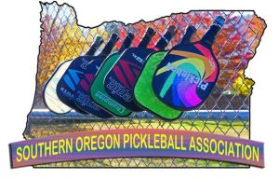
SOUTHERN OREGON PICKLEBALL ASSOCIATION
P. O. BOX 1226, TALENT, OR. 97540

September 8th 2021
Pickleball helps raise money for fire victims:
On the 8th September 2020 a devastating fire swept through the East end of the Rogue Valley in Oregon. Driven by winds over 40 mph, it left a 9-mile-long swath of destruction burning over 2,800 structures of which 2,500 were residential homes destroyed in just a few hours, devastating the towns of Talent and Phoenix.

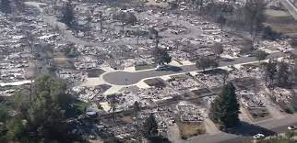

In June 2021, Southern Oregon Pickleball Association held the very first pickleball tournament in Southern Oregon, attracting 304 participants. Roughly one third of the participants came from as far as Baja, California, Phoenix, Arizona, Reno, Nevada, Helena, Montana and St George; Utah. A raffle was organized, with prizes including, lessons by local pros, paddles, wine and catered lunch and pickleball on a private court. In total $1,250 was raised. A check was presented to the local chapter of United Way who is in charge of distributing the funds for the children still displaced and in need from the fire.
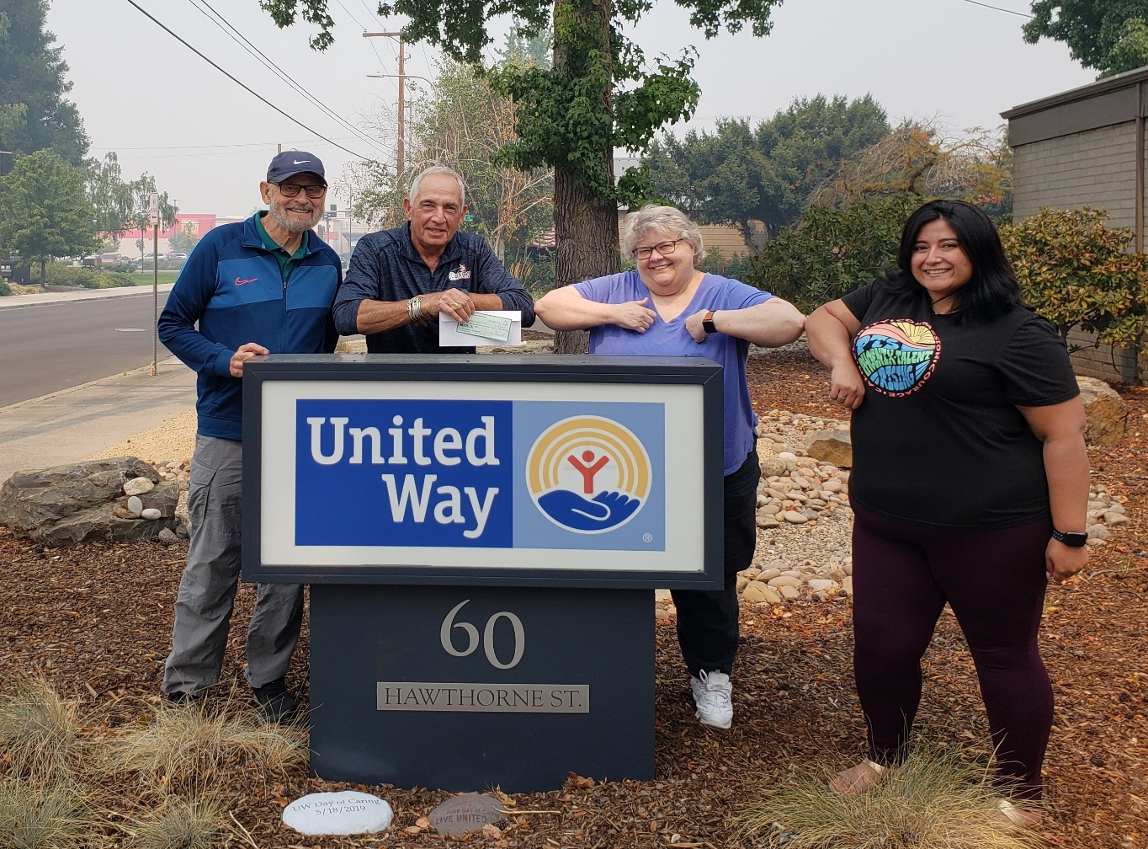

Left to right – Doug Godwin (Southern Oregon Pickleball); Norman Eisenberg (USAPA Ambassador and Marketing Director – Southern Oregon Pickleball) presenting the check to Dee Ana Everson (Executive Director – United Way of Jackson County) and Lucy Brossard, (Executive Asst. Phoenix/Talent School District).

